|  |  |  |
| --- | --- | --- |
|  |  | Creative Brief  Aromatics Private Limited |

October 8, 2016

# Client

Aromatics Private Limited is a leading company selling various beauty products for women which are scented – soaps, body creams, shower gel etc. It is an established fragrance brand in the market with continuous high sales and customers’ loyalty over the years of its existence.

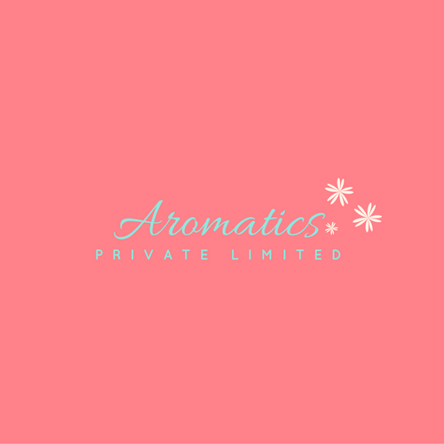

## Product

The company has come up with a new product for the Indian market – a body spray. < for women>

<Diff b/w water based, air based and perfumes>

## Market Background

The Indian market is dominated by air-based body sprays, while Aromatics aims at introducing a water-based body spray/mist for its customers.

**Marketing Objective**

The objective is to introduce a body spray as a product in the Indian market – fragrance that can be easily carried around and re applied whenever necessary - informing customers about the benefits of the product, pricing the product at a reasonable rate and promote the product’s easy availability and use.

## Competition

Whattagirl! Body sprays. While, other premium brands like Body Shop, Bath and Body Works, Victoria’s Secret, Forrest Essentials have such products, but are not active advertisers of the same as a they have a different group of target audience. Competition also majorly include the air-based body sprays – dove, park avenue, engage, Nivea etc.

## Advertising Objectives

To introduce the product in the middle-class/upper-middle class women over its competitors by emphasizing on its long lasting quality fragrance

## Media Strategy

* Print (Magazines and Glossy Newspapers)
* Television commercial
* Online
* Outdoor (hoardings and transits)

## Target Audience

Demographic – City women, working class, college going, teenagers. Psychological – women who are particular about self-grooming, fragrance and body reactions by beauty products. Behavior – aware of beauty products, interested in buying quality products, conscious of health hazards.

**Unique Selling Proposition**

Long lasting high quality fragrance

## Tone of Voice

Informative, fun, warm.